**Test Case For CheckMate:**

When the king is trapped by queen and the king can’t take the queen because the bishop is protecting the queen.

Will perform the following series of moves to reach this situation which should result in checkmate:

F7F6 E2E4 G7G5 D1H5  


**Test Case to just check for check and shows that only moves the player can make are those that move the player out of check (Showing how the Check and CheckPrevention Function Works):**

Will perform the following series of moves to show this:

D7D6 C2C3 A7A6 D1A4 C7C5 C8E6 C8D7  


**Testing For Stalemate:**

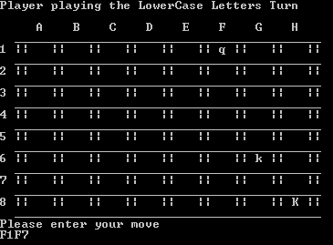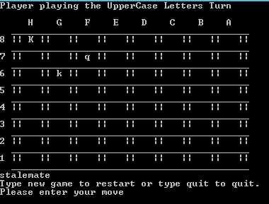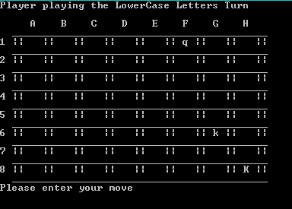The board will start out in this state and perform a move to produce a stalemate where the opponent is   
not in check but can’t move thus producing a stalemate (the move will be F1F7):

**Testing the KnightCheck() function which checks for legal moves for the knight:**    
Moves that will be carried out:  
G8F6 G1F4 G1F3 F6E5 F6E4 B1D3 B1C3 B8A5 B8A6 F3H3 F3H4 E4C3 H4G2 H4F5



**Testing the BishopCheck() function which checks for legal moves for the bishop:**Moves that will be carried out:  
C8A6 B7B6 F1H3 G2G3 C8A6 F1H3 A6F1 A6E2 H3C8 H3D7  
